Mechanical Overview

Year: _2024__ Semester: ___Spring__ Team: __5_ Project:_____________________________

Creation Date: ­______________________ Last Modified: September 14, 2023

Author: _____Yusuf Jarada___________ Email: ____yjarada@purdue.edu_______

Assignment Evaluation: See Rubric on Brightspace Assignment

* 1. Commercial Product Packaging
  2. Product #1

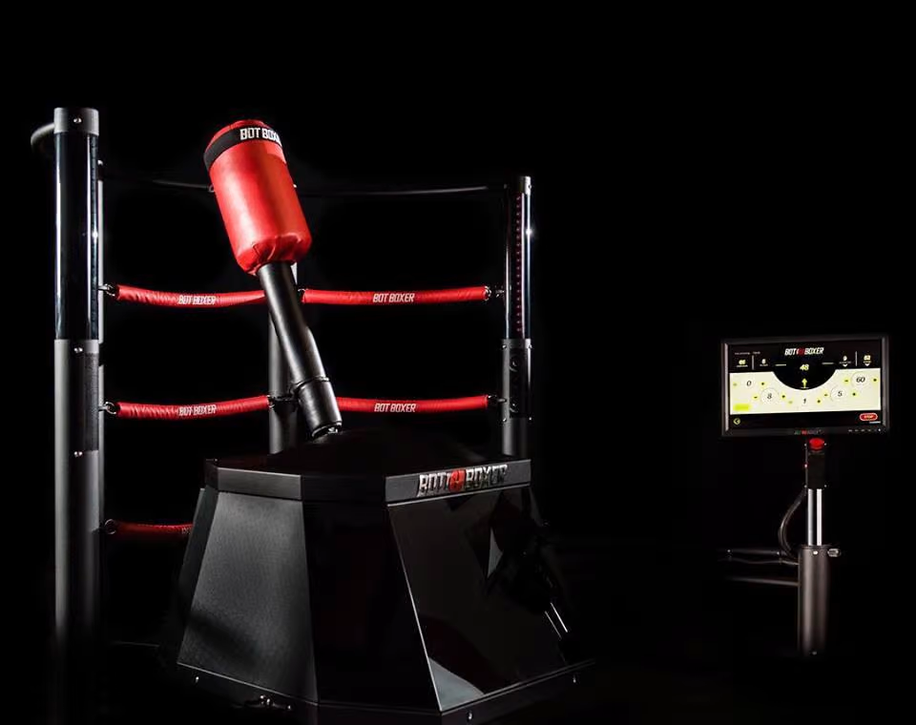

Figure 1: Packaging for Product 1

Botboxer is the closest product that I could find that has similar packaging to our own DodgeBot. The device is packaged in a black box with the end effector coming out the top with multiple cameras around the target bag. The device has a screen on the side for all the user interfaces and controls.

One of the positive aspects of this design is that it is professional and looks good. The UI also is off to the side so it cannot be damaged by the robot or person using the device. It also houses all the electronic components within the black box so there is no exposure to the outside. This keeps everything separate and safe.

Some of the negative aspects of this packaging is that the electronics are hard to access and the netting in the back of the device is unnecessary.

Our device will have similar packaging and will have the same benefits. The only difference is the camera mount will be directly above the bag and there will only be one camera in our design.

* 1. Product #2

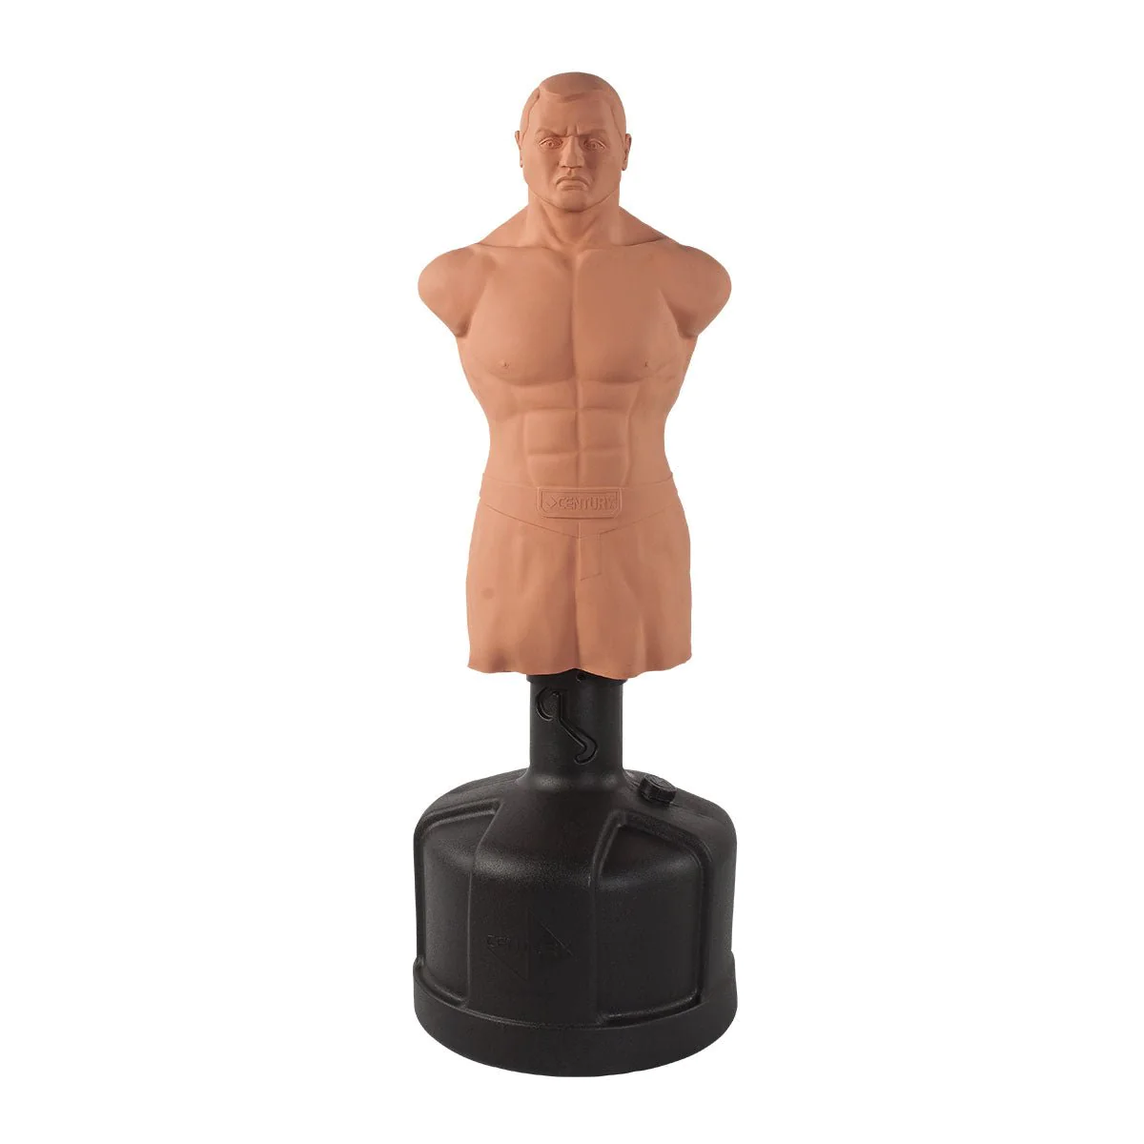

Figure 2: Packaging for Product 2

Century Bob XL was the only other product I could find that had a similar packaging to DodgeBot. The only issue is that this product has no electronic components. However, this device was the original inspiration for DodgeBot so it's packaging will be very similar to DodgeBot. The positive aspects of this packaging are its simple design, and the fact that it holds itself to the ground.

There are not many negative aspects of this packaging. One possible one is that the device is not very portable, but this device would never really need to travel much. Overall, this is a very good design that has been around for many years and has stayed relevant as a tool in fighting gyms.

DodgeBot will use a very similar packaging but with the added complexity of the motors and cameras

2.0 Project Packaging Description

DodgeBot will be packaged similarly to the 2 examples given above. Fig 2 in Appendix 1 will give a rough idea of how the final assembly will be. The PCB will be housed in the Motor Assembly within the base housing. The housing is inspired by the Century Bob XL design and will have a similar shape. The box is shown in the figure for simplicity of drawing. The housing and end effector will be made of aluminum. The camera will be mounted above the entire assembly and will interface with the laptop. The laptop will interface with the PCB and the camera. Finally, the PCB will interface with the motor assembly which is shown in CAD below in Appendix 1 figure 1.

3.0 Sources Cited

[1] “BotBoxer | Smart Boxing Machine for an Ultimate Workout,” *www.skytechsport.com*. <https://www.skytechsport.com/botboxer-home>

‌

[2] “BOB XL - Body Opponent Bag | Punching Bag | Century,” *Century Martial Arts*. <https://centurymartialarts.com/products/bob-xl-body-opponent-bag> (accessed Feb. 11, 2024).

‌

Appendix 1: CAD Model Illustrations + Drawing

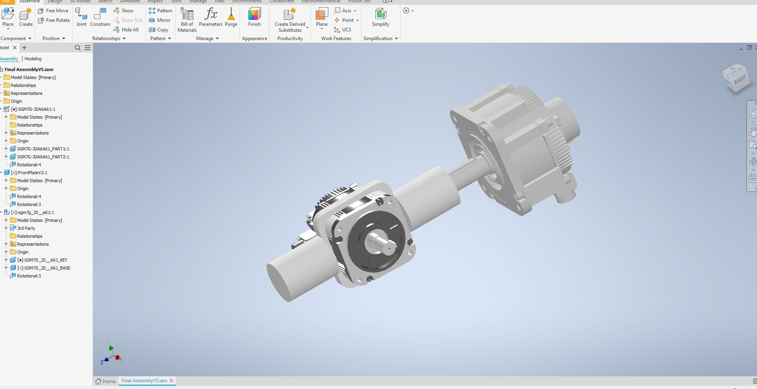

*Fig.1*

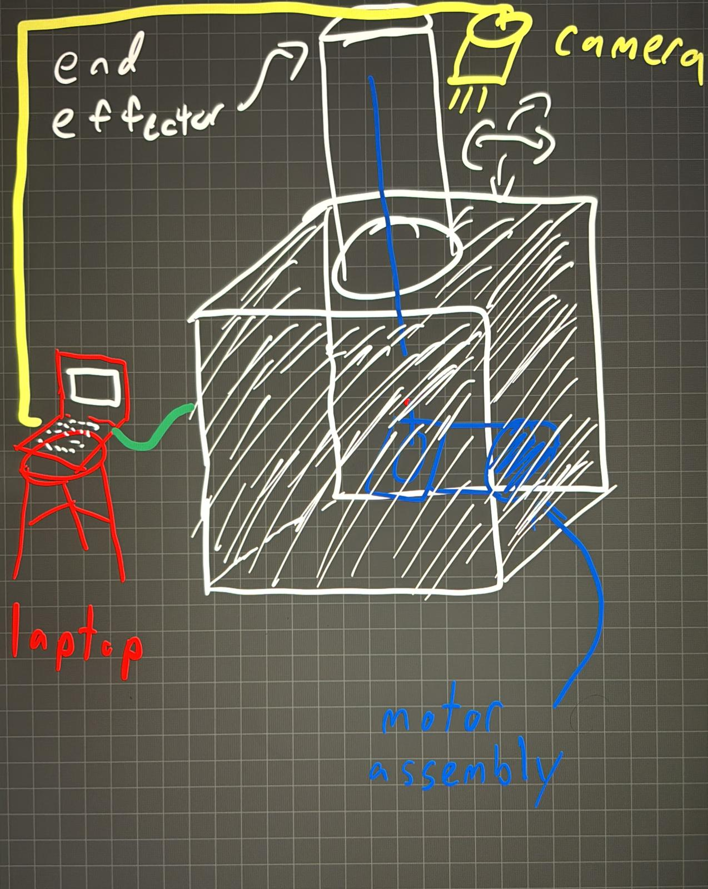*Fig 2*

Appendix 2: Project Packaging Specifications

|  |  |  |  |
| --- | --- | --- | --- |
| *Material* | *Tooling* | *Weight* | *Cost* |
| *Aluminum* | *Drill/CNC* | *10lbs* | *$30* |
| *Punching Bag* | *N/A* | *1lb* | *$20* |
| *Motors(both)* | *N/A* | *50lb (combine)* | *N/A (from School)* |
| *PCB* | *Soldering* | *0.1lb* | *$30* |
| *Camera* | *NA* | *0.1lb* | *$5* |
| *Wiring* | *Soldering/Crimping* | *5lb Total* | *$2* |

Appendix 3: PCB Footprint Layout

